**Assessment 1**

**Code**

<!DOCTYPE html>

<html lang="en">

<head>

    <meta charset="UTF-8">

    <meta name="viewport" content="width=device-width, initial-scale=1.0">

    <title>My Landing Page</title>

    <style>

        body {

            margin: 0;

            padding: 0;

            font-family: Arial, sans-serif;

        }

        .navbar {

            background-color: #333;

            overflow: hidden;

        }

        .navbar a {

            float: left;

            display: block;

            color: #f2f2f2;

            text-align: center;

            padding: 14px 20px;

            text-decoration: none;

            transition: background-color 0.3s;

        }

        .navbar a:hover {

            background-color: #ddd;

            color: white;

        }

        .background-image {

            background-image: url('https://bestwallpapers.in/wp-content/uploads/2018/05/cute-black-dog-4k-wallpaper-3415x2451.jpg');

            background-size: cover;

            background-position: center;

            height: 100vh;

            display: flex;

            justify-content: center;

            align-items: center;

            color: white;

            text-align: center;

        }

        .img{

            background-image: url('https://wallpapers.com/images/featured/dog-wj7msvc5kj9v6cyy.jpg');

            background-position: center;

            height: 100vh;

            display: flex;

            justify-content: center;

            align-items: center;

            color: white;

            text-align: center;

        }

        .content {

            text-shadow: 2px 2px 4px rgba(0,0,0,0.5);

        }

        .button {

            display: inline-block;

            background-color: black;

            border: none;

            color: white;

            padding: 15px 25px;

            text-align: center;

            text-decoration: none;

            display: inline-block;

            font-size: 16px;

            margin: 4px 2px;

            cursor: pointer;

            border-radius: 10px;

        }

    </style>

</head>

<body>

<div class="navbar">

    <a href="#home">Home</a>

    <a href="#about Us">About Us</a>

    <a href="#Contact">Contact Us</a>

    <a href="#services">Our Services</a>

</div>

<div id="home" class="background-image">

    <div class="content">

        <h1>Man's Best Friend</h1>

        <p>That warm fuzzy reaction you get when your dog licks your hand or your cat rubs against your leg isn't merelya fluke.Get yorself a new friend today</p>

        <a href="#" class="button">Adopt Now</a>

        <a href="#" class="button">See Our Breeds</a>

    </div>

</div>

<div id="about Us" class="img">

    <div class="content">

        <div id="about" class="section">

            <div class="section-content">

                <h2>About Us</h2>

                <p>Welcome to Paws and Whiskers Adoption Center!</p>

                <div class="about-quote">

                    <blockquote>"Saving one animal may not change the world, but for that one animal, the world changes forever."</blockquote>

                </div>

                <div class="about-info">

                    <p>At Paws and Whiskers, we believe that every pet deserves a second chance and a loving home. </p>

                    <p>With a team of dedicated volunteers and staff, we provide compassionate care and support to animals who have been abandoned, neglected, or abused. </p>

                    <p>Before adoption, each pet receives comprehensive medical care, vaccinations, and spaying/neutering to ensure their health and well-being. </p>

                    <p>By choosing to adopt from Paws and Whiskers, you're not just bringing home a pet - you're changing a life. </p>

                    <p>Join us in our mission to make a difference in the lives of animals. Visit our adoption center today and find your new best friend!</p>

                </div>

            </div>

        </div>

    </div>

</div>

</body>

</html>

**Code for the webpage**

**Output**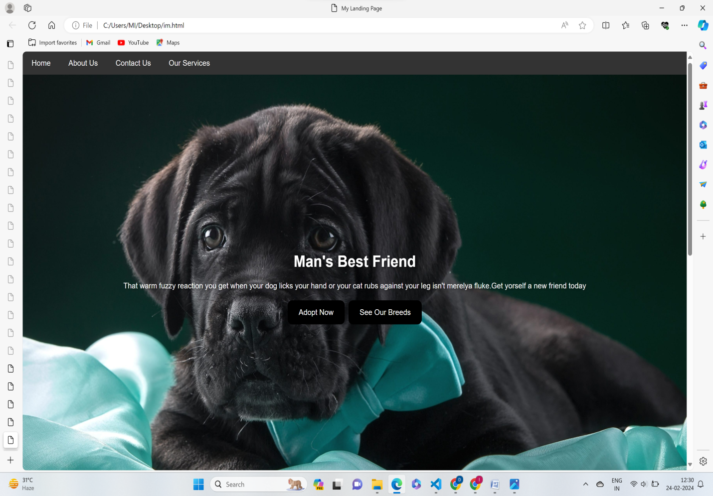

**Output of Home Page**

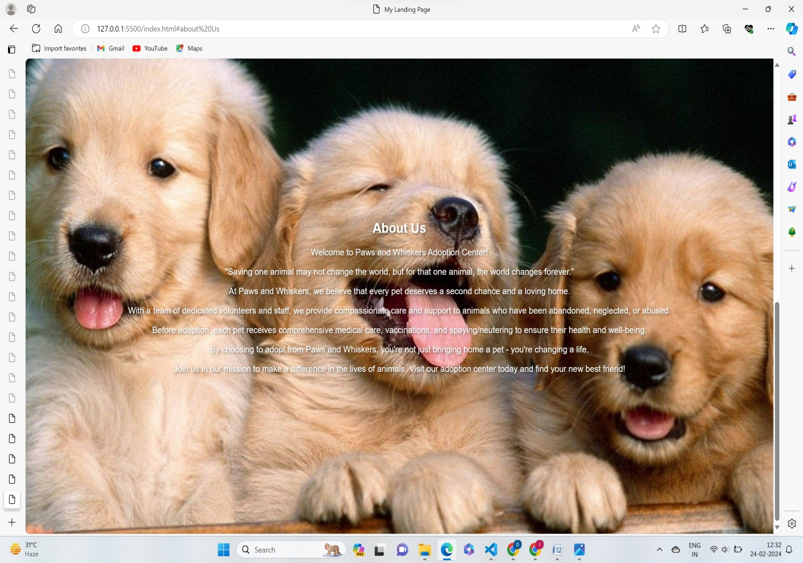

**Output of About Us page**